**Capstone Project - The Battle of Neighborhoods**

**Opening Arabic Restaurant in Paris**

**Background**

Paris is the capital and largest city of France, as well as its cultural, industrial, and financial center. The geographical coordinate of Paris, France are 48.8566969, 2.3514616. Paris received 38 million visitors in 2019, measured by hotel stays. It was ranked as the second most visited travel destination in the world in 2019, after Bangkok and just ahead of London [1]. Therefore, opening a restaurant in Paris will have a big opportunity to be a successful business.

**Introduction**

In this project, I will determine which place is good for opening Arabic Restaurant in Paris, France

* I will convert address data into their equivalent latitude and longitude values.
* For Paris neighborhood data, I will use Wikipedia <https://en.wikipedia.org/wiki/Category:Districts_of_Paris>
* I will use the Foursquare API to explore Paris neighborhoods and to get venues in neighborhoods.
* I will try to use the Foursquare API to get venue ratings and likes in neighborhoods (depending if there is rating available)
* I will use the k-means clustering and Agglomerative algorithms to complete clustering task
* I will use the Folium library to visualize the neighborhoods, venues, clusters in Paris

**Table of Contents**

* 1. Download and Explore Neighborhoods Dataset
  2. Load and Analyze Venues of Neighborhoods in Paris
  3. Cluster Neighborhoods using Agglomerative Clustering
  4. Discussion & Results
  5. Conclusion

1. *Download and Explore Neighborhoods Dataset*

Downloading the data and importing all necessary packages. Below is screen shot of the data after downloading and cleaning them. I used Wikipedia, "Category: Districts of Paris" for getting neighborhoods of Paris (<https://en.wikipedia.org/wiki/Category:Districts_of_Paris>). I used python geocoder library to get geographical coordinates of neighborhoods

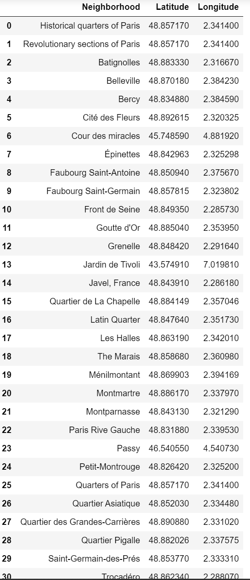

#### Create Paris map with neighborhoods superimposed

Let's see locations of neighborhoods on map. In here, I use folium library to draw map

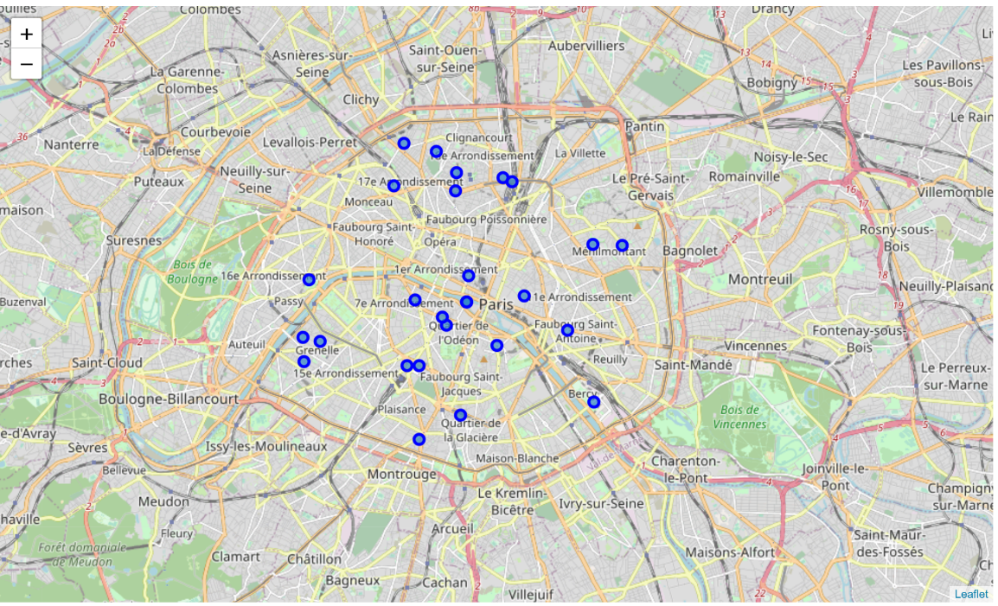

1. *Load Venues and Analyze Neighborhoods in Paris*

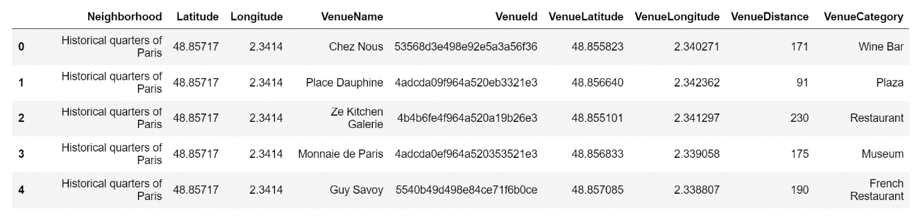We will use Foursquare API for getting venues of neighborhoods. I get venue list with 1 km distance to neighborhood's center. By using Foursquare API I got venues 1 km around the center of each neighborhood with limit 100 venue. I merged data with Neighborhood data. Head of the merged data is as below

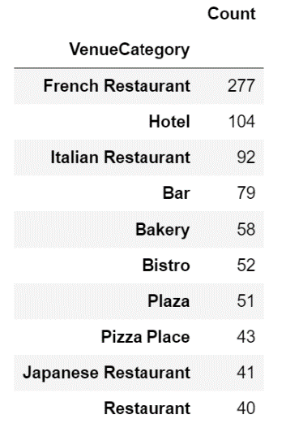

There are 225 unique venue categories in Paris and top 10 venue counts is as shown to the left

I filtered All restaurants and Turkish restaurant. We can see from histogram of restaurants, **10** neighborhoods have **no** Arabic restaurant

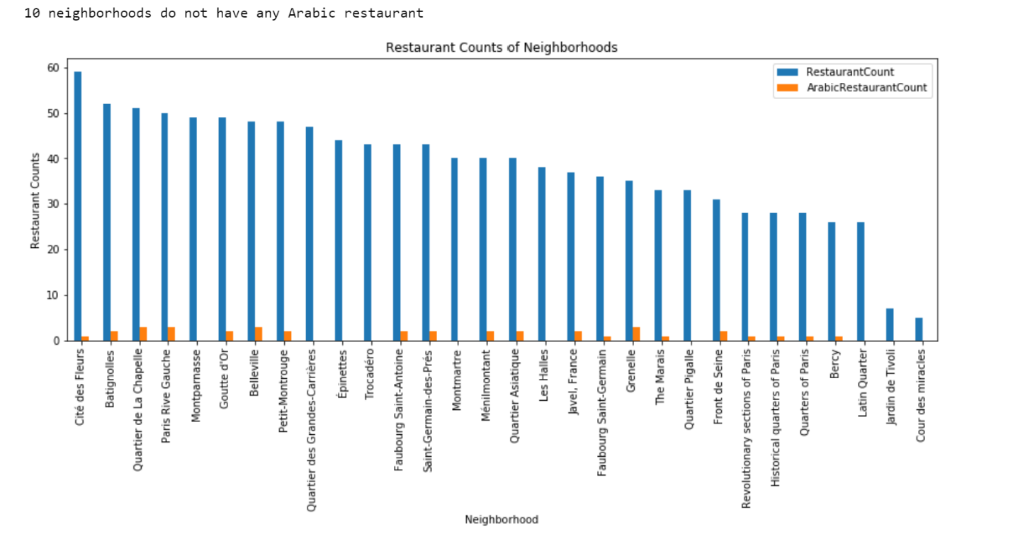

We can see from the Graph:

* Cite des Fleurs is the neighborhood having most restaurants
* Montparnasse, Quartier des Grandes, Epinettes and Trocadero have lots of restaurants, but no single Arabic restaurant
* Jardin de Tvoli and Cour des miracles are neighborhoods having least number of restaurants
* 10 neighborhoods do not have any Arabic restaurant. we can choose one of these to open restaurant. To filter more let's continue

#### Show distribution of Arabic restaurants

Let's create a map showing distribution of Arabic restaurants and try to extract some meaningful info from that. Also, let's show borders of Paris on our map and a few circles indicating distance of 2km, 4km, 6km and 10km from Paris center

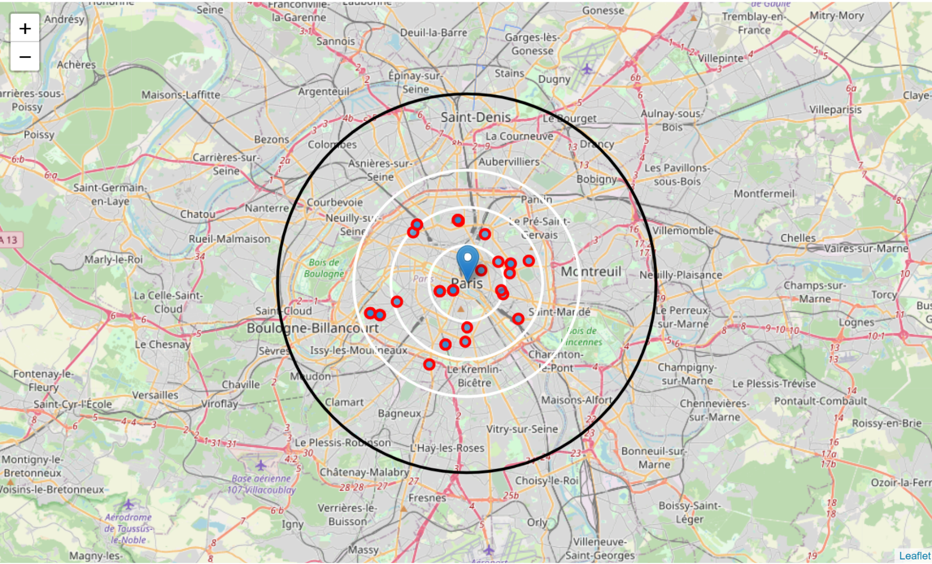

From the map, we can see that there are

* Many restaurants in 4 km to the center
* Enough restaurants between 4-6 km to the center
* There are not any Arabic restaurants after 6 km to center
* It looks hard to find location from this view as resturant is scattered
* better maybe to filter by neighborhood and look for better chance

#### Show neighborhoods which has no Arabic restaurant on map

Green markers are Neighborhoods without any Arabic restaurants

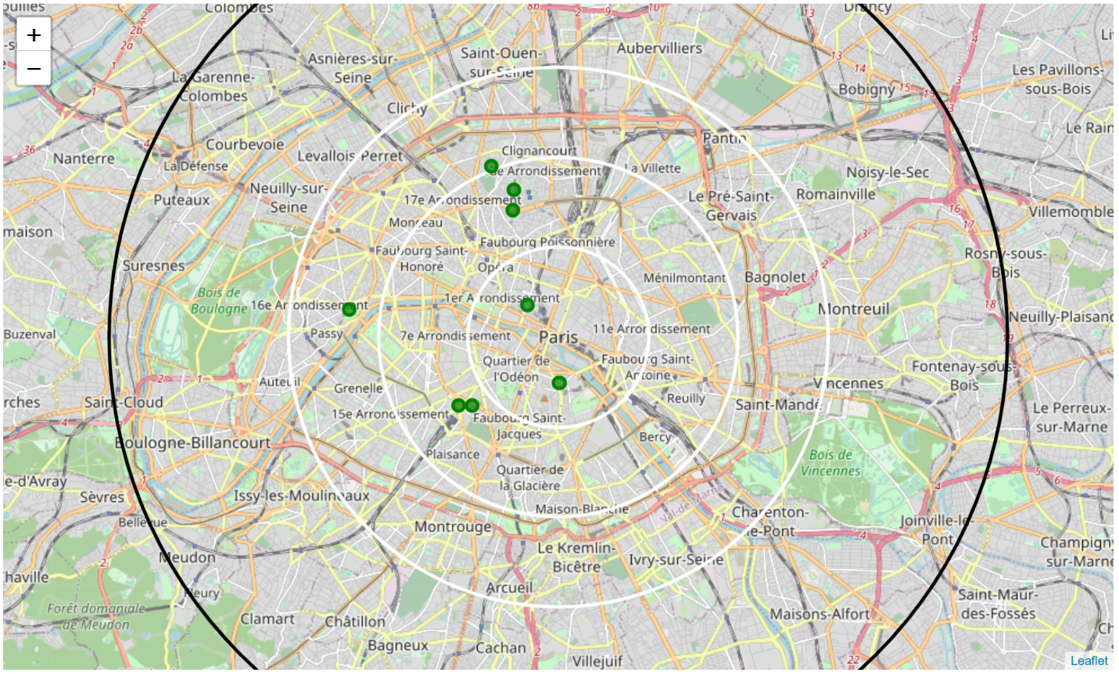

1. *Cluster Neighborhoods using Agglomerative Clustering*

I will use hierarchical agglomerative clustering method to compare neighborhoods among neighborhoods

First, find the number of clusters. Let's use SciPy library to create the dendrograms for our dataset

I used Agglomerative Clustering to cluster neighborhoods according to count of venue categories in each neighborhood. According to the below graph, I decided to separate our neighborhoods into 6 clusters (cut at distance of 20, horizontal black line).

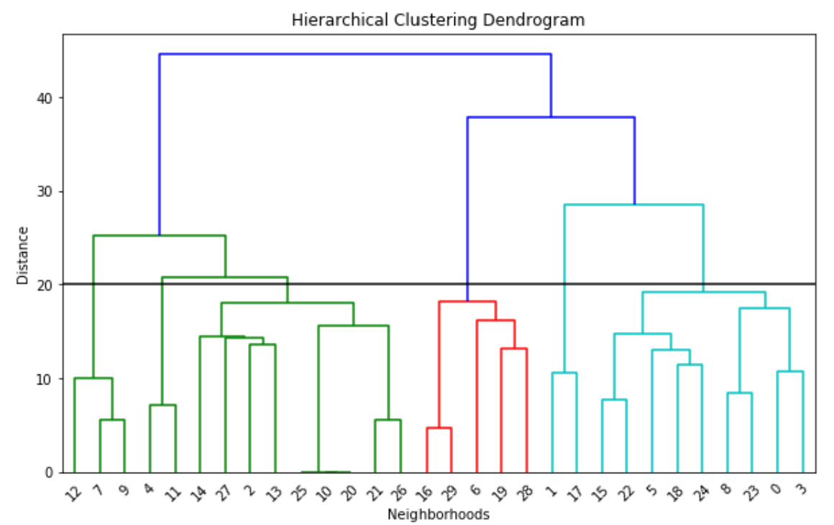

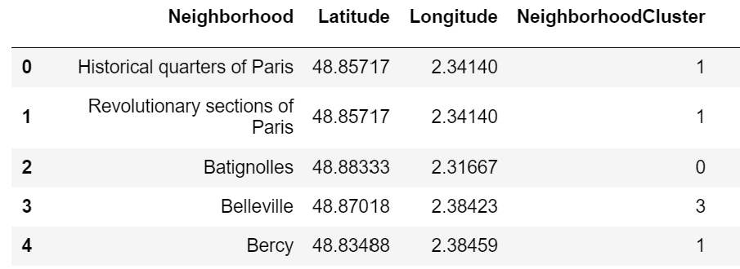

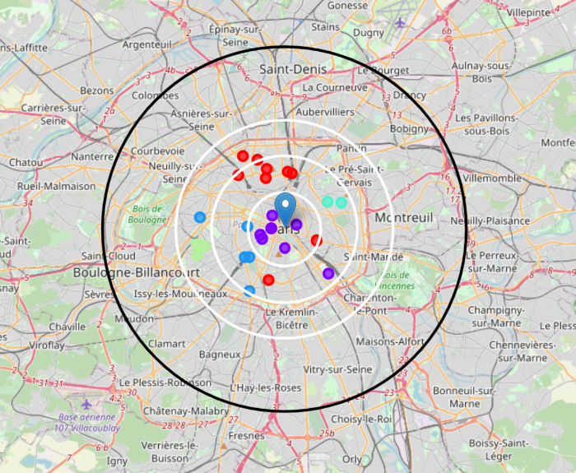

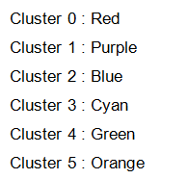

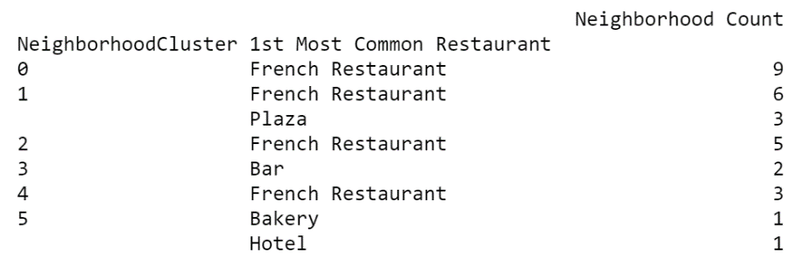

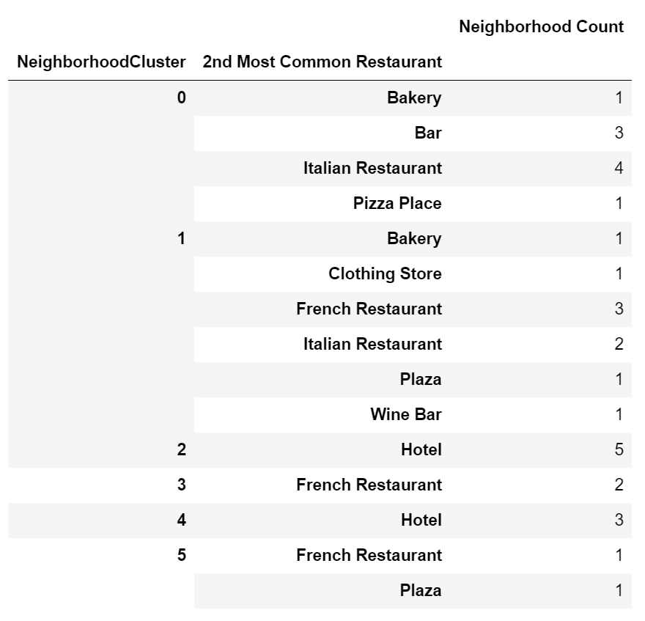

We can see cluster categories as below

* Cluster 0 (Red): French and Italian Restaurant, Pizza, Bakery and Bar
* Cluster 1 (Purple): French and Italian Restaurant, Clothing stores, Plaza
* Cluster 2 (Blue): French Restaurant and Hotel
* Cluster 3 (Cyan): French Restaurant, Bar
* Cluster 4 (Green): French Restaurant and Hotel
* Cluster 5 (Orange): Bakery and Hotel

1. *Discussion & Results*

Cluster 4 and 5 suffers from restaurant. Especially there is very less Arabic restaurant 4-6km from center and no after 6Km from center. We can think about Cluster 4 area

Cluster 0 especially likes French tastes, may be this part will not like Arabic tastes. We can only think about 1 location may be.

Cluster 1, 2, 3 are centers full of restaurants especially French and Italian so it maybe not a good idea.

1. *Conclusion*

Possible Neighborhoods to set up a Arabic restaurant:

* Montparnasse, Quartier des Grandes, Epinettes and Trocadero have lots of restaurants, but no single Arabic restaurant
* Since Montparnasse and Trocadero are the best as they located in Cluster 4 as explained above
* Quartier des Grandes could be 2nd option to think about one location as it is located in cluster 0